Directions: Sketch the graphs of the following polynomial functions.
$f(x)=3x^{5}−\text{24}x^{4}+\text{51}x^{3}−\text{30}x^{2}$ $f(x)=x^{4}+4x^{3}−\text{10}x^{2}−\text{28}x−\text{15}$ $f(x)=4x^{4}−\text{16}x^{3}−\text{19}x^{2}−5x$

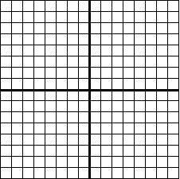
________________________________________________________________________________________________

$f(x)=−3x^{5}+\text{15}x^{3}−\text{12}x$ $f(x)=−2x^{4}+\text{20}x^{3}−\text{46}x^{2}+\text{28}x$ $f(x)=−x^{4}−\text{10}x^{3}−\text{20}x^{2}+\text{10}x+\text{21}$

